**Practical Task: SQL Aditya More Date: 07/02/25**

Q1. Create Table name as Player with column id, name, run and age and perform following operation on table



1. Add new column address using alter command

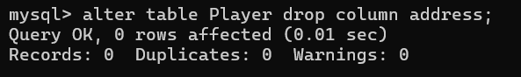

1. Change run column name to total run

  Q2. Insert 10 records in the Player table.



Q3. Select all records of player.

 Q4. Delete player whose id is 1.

Q5. Update the player run 40000 whose id is 1.

Q6. fetch player whose run is 10000, 20000,30000,5000.

Q7. Fetch max run from player table.

 Q8. fetch min run from player table.

Q9. find the average run of the player table.

Q10. find the sum of all players run.

Q11. count total number of players from table.

Q12. WA SQL query fetch player whose run is not 50000.

Q13. WA SQL Query to fetch player whose run is 5000 and name is not abc.

Q14 drop column address from player.

Q15. drop table player from database.

